DBMS LAB WEEK 11
Topic: PL/SQL July 11, 2023

Basic Hello world program:

SET Serveroutput ON
DECLARE
message varchar2(20) := 'Hello world';
BEGIN
dbms_output.put_line(message);
END;
/

Output:

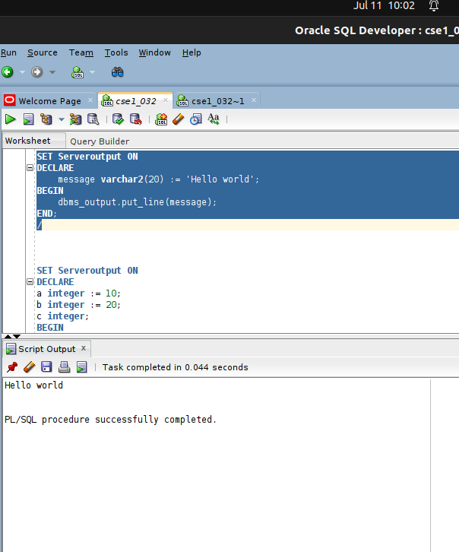

1. Create anonymous block and perform all DML operations.

create table employee
(employee_id number(4) NOT NULL,
first_name varchar2(20) NOT NULL,
last_name varchar2(20) NOT NULL,
email varchar2(30) NOT NULL,
hire_date date NOT NULL,
job_id number(3) NOT NULL,
salary number(6) not null);
Table Employees was created.

Insertion

BEGIN
INSERT INTO employee
(employee_id, first_name, last_name, email,
hire_date, job_id, salary)
VALUES(5001,'Ruth', 'Sharon','r@gmail.com','27/09/2003', '101', 400000);
END;

Output:

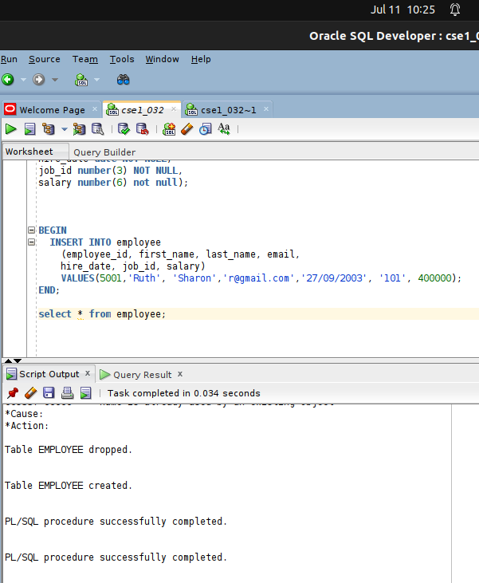

Table Employee after insertion:

Updation:

DECLARE
sal_increase employee.salary%TYPE := 20000;
BEGIN
UPDATE employee
SET salary = salary - sal_increase
WHERE job_id = '102';
END;
/

Output:

Table employee after updation

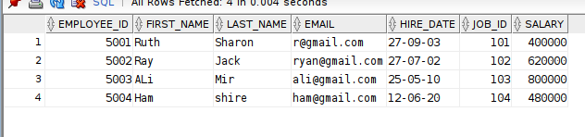

DELETION:

DECLARE
wage employees.salary%TYPE := 800000;
BEGIN
DELETE FROM employee
WHERE salary = wage;
END;

OUTPUT:
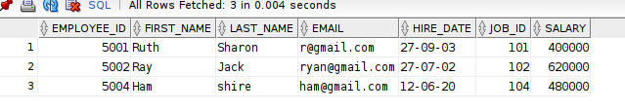
Table EMPLOYEE AFTER DELETION:

2. Practice all the declarations of variables. Different vertsions of assigning values to variables.

SET Serveroutput ON
DECLARE
x Number(10) := 100;
y NUmber(10) default 100;
z Number(10) not null := 300;
a integer := -3;
sname varchar2(20) := 'AKil';
BEGIN
dbms_output.put_line('value of x = '||x);
dbms_output.put_line('value of y = '||y);
dbms_output.put_line('value of z = '||z);
dbms_output.put_line('Value of negative : '||a);
dbms_output.put_line('NAME OF STUDENT : '||sname);
END;

OUTPUT:

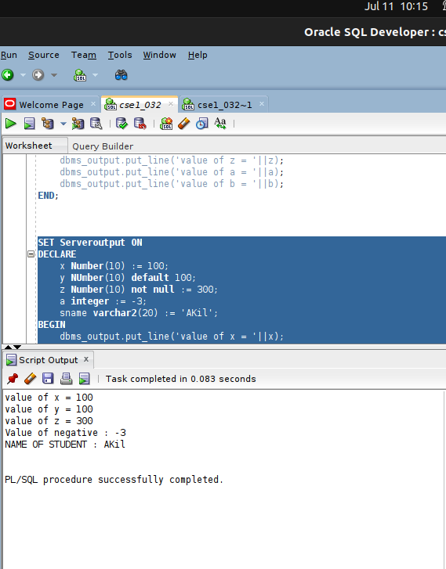

3. Implicit cursor attributes containing block

%FOUND
%NOTFOUND
%ISOPEN
%ROWCOUNT

PL/SQL Code to add bonus to employee salaries and return the number of rows affected using implicit cursors:

DECLARE
total_rows number(2);
bonus employee.salary%TYPE := 2000;
BEGIN
UPDATE employee
SET salary = salary + bonus;
IF sql%notfound THEN
dbms_output.put_line('no employees selected');
ELSIF sql%found THEN
total_rows := sql%rowcount;
dbms_output.put_line( total_rows || ' employees selected ');
END IF;
END;
/

OUTPUT:
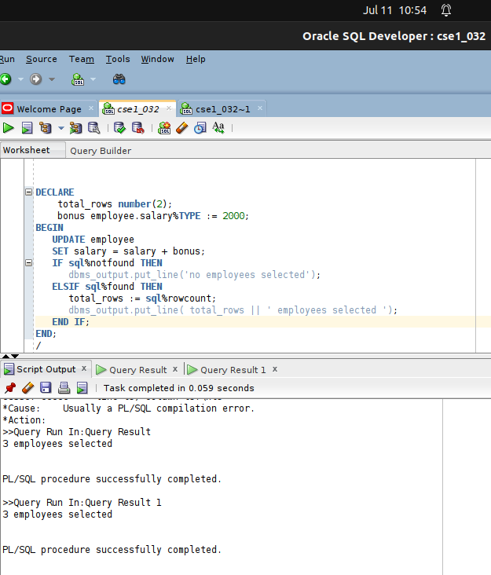

Table after updation:
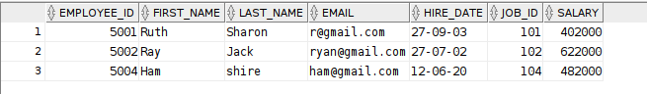

4) CONTROL STRUCTURES:
Type-1: Conditional
Eg-1: Program to determine grade from user input using switch case
DECLARE
grd CHAR(1);
BEGIN
grd := '&new_grd';
CASE grd
WHEN 'A' THEN dbms_output.Put_line('Your Grade is: Outstanding');
WHEN 'B' THEN dbms_output.Put_line('Your Grade is: Excellent');
WHEN 'C' THEN dbms_output.Put_line('Your Grade is: Very Good');
WHEN 'D' THEN dbms_output. Put_line('Your Grade is: Average');
WHEN 'F' THEN dbms_output.Put_line('Your Grade is: Poor');
ELSE dbms_output.Put_line('No such grade in the list.');
END CASE;
END;
/
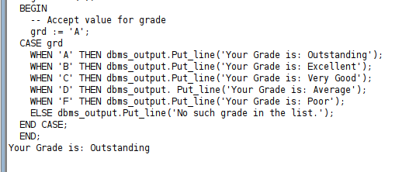
\

Eg-2: Program to determine value of variable from user input:

DECLARE
a number(2);
BEGIN
a := '&enter_value_of_a';
IF ( a = 10 ) THEN
dbms_output.put_line('Value of a is 10' );
ELSIF ( a = 20 ) THEN
dbms_output.put_line('Value of a is 20' );
ELSIF ( a = 30 )
THEN
dbms_output.put_line('Value of a is 30' );
ELSE
dbms_output.put_line('None of the values is matching');
END IF;
dbms_output.put_line('Exact value of a is: '|| a );
END;
/

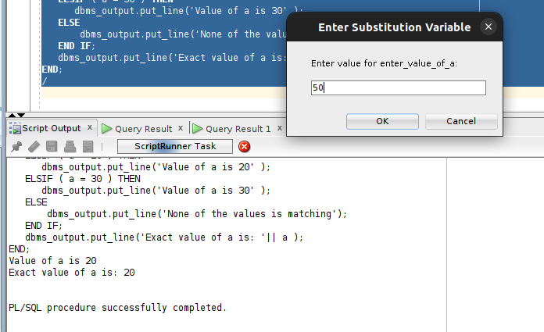

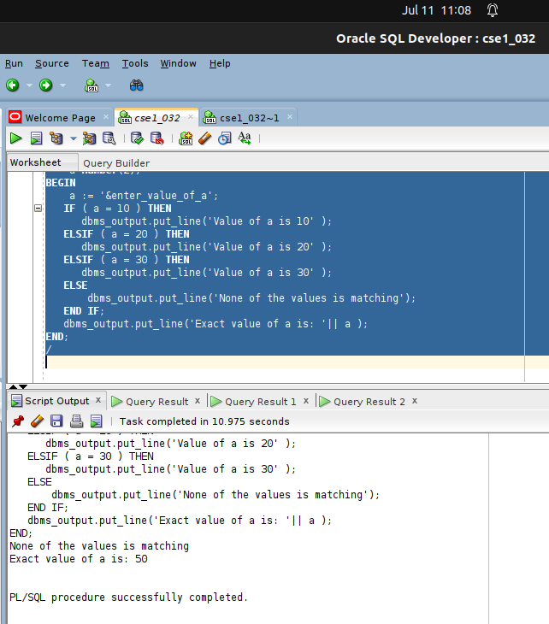
Type-2: Iterative

Eg-1: PL/SQL program to print natural numbers upto to 10 in ascending order (using exit loop)
SET SERVEROUTPUT ON
DECLARE
i NUMBER := 1;
BEGIN
LOOP
EXIT WHEN i>10;
DBMS_OUTPUT.PUT_LINE(i);
i := i+1;
END LOOP;
END;
Output:
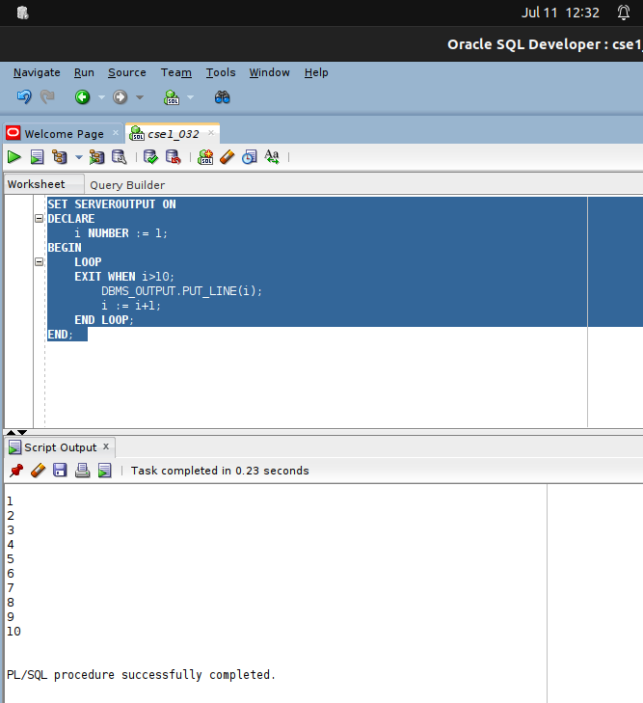

Eg-2: PL/SQL program to print natural numbers from 10 in descending order (using exit loop)
SET SERVEROUTPUT ON
DECLARE
i NUMBER := 10;
BEGIN
LOOP
EXIT WHEN i<1;
DBMS_OUTPUT.PUT_LINE(i);
i := i-1;
END LOOP;
END;

Output:
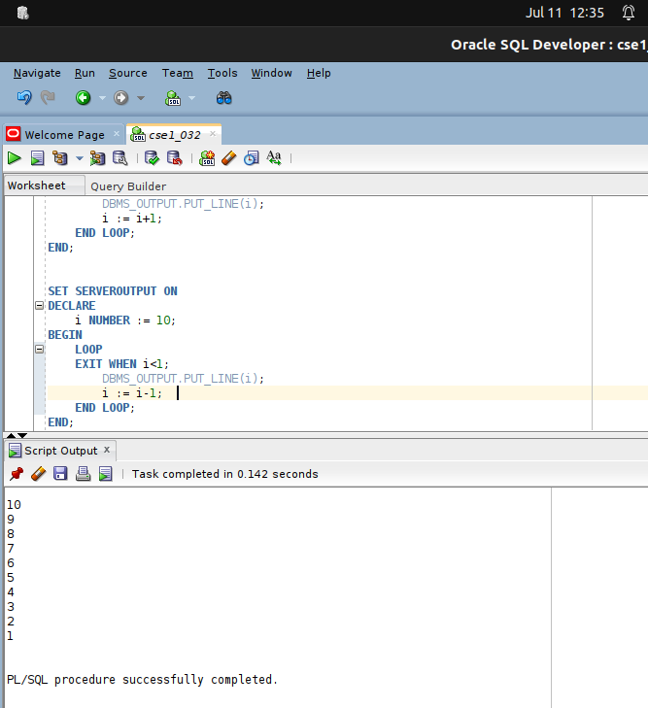

Eg-3: PL/SQL program to print natural numbers upto to 10 in ascending order (using while loop)
SET SERVEROUTPUT ON
DECLARE
i NUMBER := 1;
BEGIN
while i<=10 loop
DBMS_OUTPUT.PUT_LINE(i);
i := i+1;
END LOOP;
END;
Output:
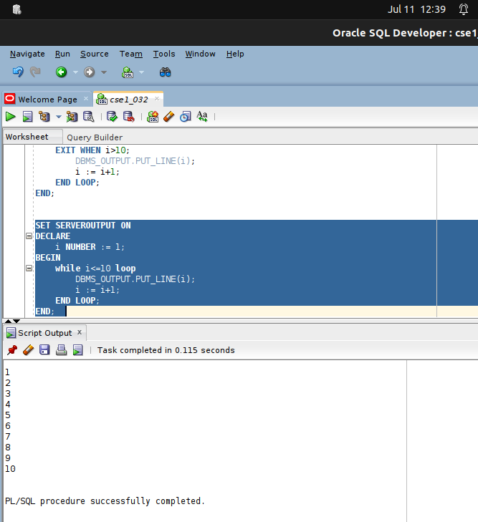

Eg-4: PL/SQL program to print natural numbers from 10 in descending order (using while loop)
SET SERVEROUTPUT ON
DECLARE
i NUMBER := 10;
BEGIN
while i>=1 loop
DBMS_OUTPUT.PUT_LINE(i);
i := i-1;
END LOOP;
END;

Output:

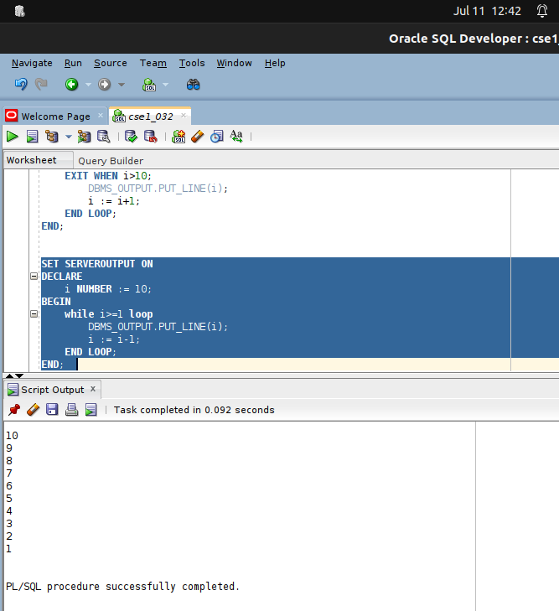

Eg-5: PL/SQL program to print natural numbers upto 10 in ascending order (using for loop)

BEGIN
FOR i IN 1..10 LOOP
DBMS_OUTPUT.PUT_LINE(i);
END LOOP;
END;
Note:
a- You don't need to declare the counter variable explicitly because it is declared implicitly in the declaration section.
b- The counter variable is incremented by 1 and does not need to be incremented explicitly.
Output:
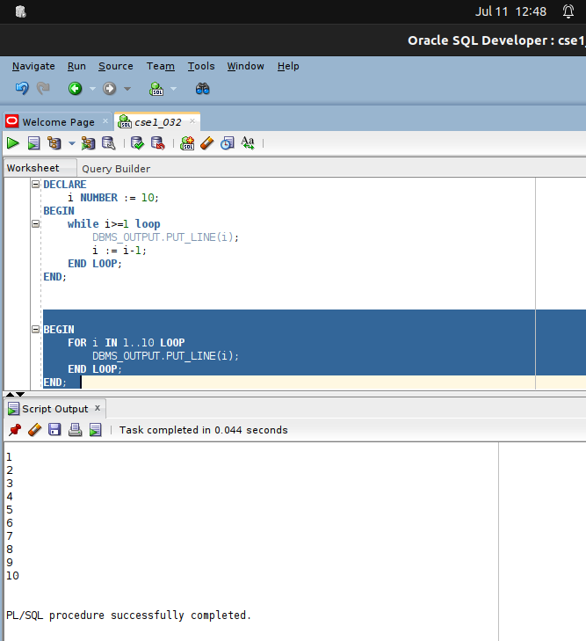
Eg-6: PL/SQL program to print natural numbers from 10 in Reverse / descending order (using for loop)

SET SERVEROUTPUT ON
BEGIN
FOR i IN reverse 1..10 LOOP
DBMS_OUTPUT.PUT_LINE(i);
END LOOP;
END;

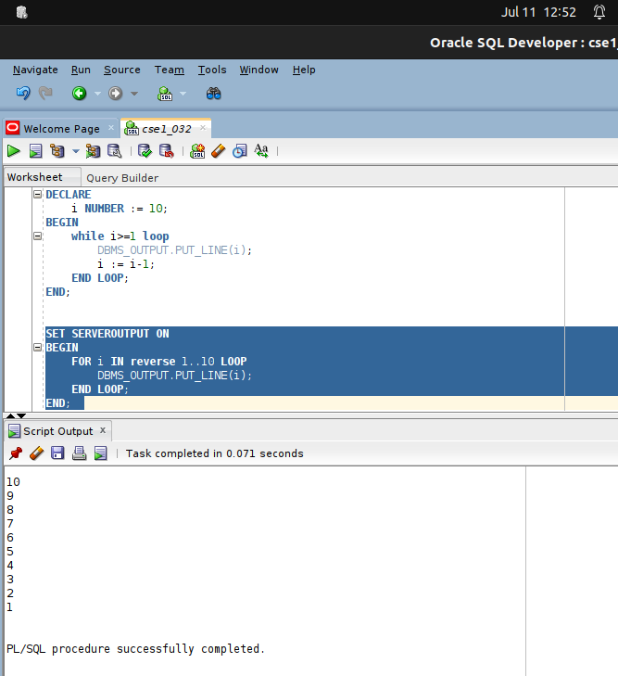
Output:

